Tips en adviezen over mast, want en trimmen
Seldén Masts
Januari 2007
Vertaling (mee bezig): Aike van der Hoeff, versie 18-11-2011
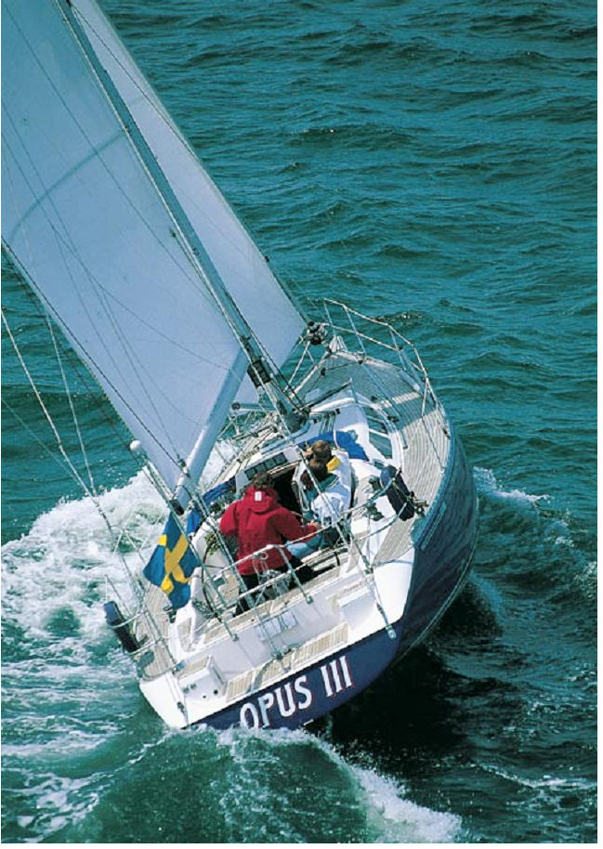

Inhoud

1. Introductie 4
2. Mast-want types 6
3. Voor- en achterstag (longitudinaal) 8
4. Want (lateraal) 10
5. Lopend want 11
6. Voorbereiden voor plaatsen mast 15
7. Controleren van de mast 16
8. Onder de kraan 19
9. Doorlopende masten 21
10. Alternative rigging of jib furling system 25
11. Spannen van het want 27
12. De “duimstok methode” 28
13. Trimmen voor veiligheid 29
14. Masthead rigs 31
14.1 Eén stel zalingen in lijn, mast op dek, single aft lower shrouds and baby stay 31
14.2 Eén stel zalingen in lijn, mast op dek, forward and aft lower shrouds 33
14.3 Masttop getuigd, meerdere gepijlde zalingen, mast op dek, forward and aft lower shrouds. Alternatively baby stay and aft lower shrouds. 35
14.4 Masttop getuigd, meerdere zalingen in lijn, mast op dek, forward and aft lower shrouds. Alternatively, baby stay and aft lower shrouds. 36
14.5 Fractioneel getuigd, één stel gepijlde zalingen, single aft lower shrouds, mast op dek 38
14.6 Fractioneel getuigd, meerdere stellen gepijlde zalingen, mast op dek 39
14.7 Fractioneel getuigd, meerdere stellen zalingen in lijn, mast op dek, forward and aft lower shrouds. Alternatively baby stay and aft lower shrouds. 40
15. 19/20 rig and similar 41
16. B & R tuigage (Bergström & Ridder) zonder bakstag 43
17. Gieken 46
17.1 Slab-reefing boom 46
17.2 Single-line reefing 47
17.3 In-mast furling (manual version) 48
18. Neerhouder-ophouder 49
19. Werken in de hoogte 50
20. De mast strijken (winter onderhoud) 52
21. Beschadigd of cosmetic flaws? 56
22. Storage 56
23. Mounting new fittings 57
24. Masten die blijven staan 58
25. Boot op de wal met staande mast 58
26. Enkele rekenprincipes t.a.v. mast en want 59
27. Positive roach + in-mast furling 61
28. Sail Slides and sail entry 62
29. The Selden product range 63

Introductie
‘The rig’ (mast en want) is de combinatie van masten, gieken en gaffels, verstaging en alle andere soorten uitrusting. Het is duidelijk dat mast en want een onmisbaar deel van uw jacht vormen. Om goed te kunnen trimmen, voor de beste combinatie tussen prestatie, betrouwbaarheid en veiligheid, heb je een bepaalde hoeveelheid kennis nodig. Met “Tips en adviezen” delen we met u onze praktijkervaring. Het meeste weet u waarschijnlijk al, maar er valt altijd wel wat te leren.
Het eerste deel van dit boek beschrijft het stellen van de mast en een aantal algemene voorbereidingen. Het is van belang deze informatie te lezen, ongeacht het type tuigage dat u heeft.
Nadat u dat gedaan heeft kunt u de tuig instructie die bij uw type want hoort volgen. Dit is natuurlijk belangrijk vanwege de veiligheid, maar het is ook een voorwaarde die wij stellen, anders kunnen we niets garanderen.
We laten u ook zien hoe ons stelsel van mast en want in de praktijk gehanteerd moet worden, plus hoe u voor de spullen moet zorgen, zodat ze lang meegaan.
Als u “Tips en adviezen” leest zult u soms onbekende technische termen tegenkomen. Zeiltaal is beroemd vanwege het gebruik van woorden die voor velen onbekend zijn. Het lijkt ons goed als u onze productcatalogus bij de hand hebt als “Tips en adviezen” leest, voor een alfabetische index en afbeeldingen van de meeste onderdelen van de masten en het want.
We hopen dat u iets hebt aan “Tips en adviezen”.

We wensen u gunstige wind,

The Seldén Group
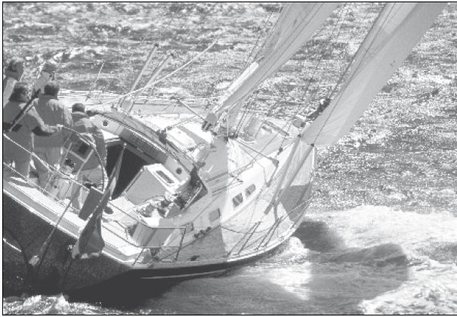

Mast-want types
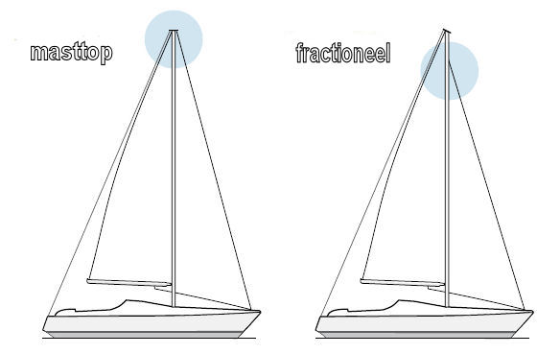
Afbeelding 1 Top getuigd en fractioneel getuigd

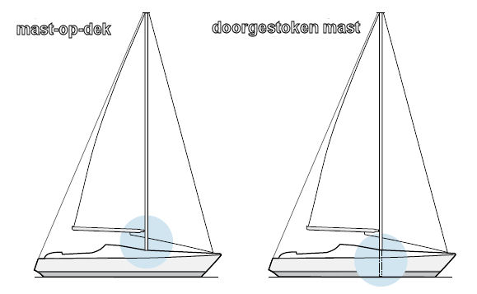
Afbeelding 2 Op het dek staande mast en doorgestoken mast
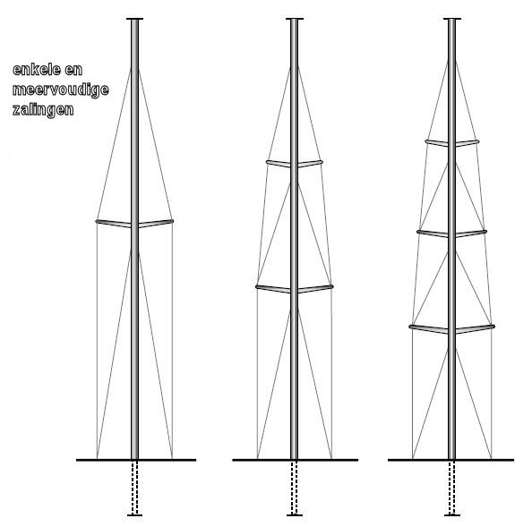
Afbeelding 3 Mast-want met enkele en meervoudige zalingen

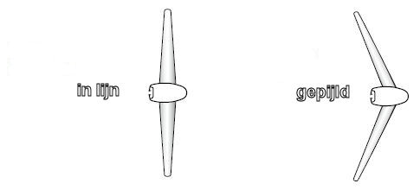
Afbeelding 4 Van boven gezien: zalingen in lijn en gepijld

Voor- en achterstag (longitudinaal)
Zie Afbeelding 5.

Bakstag: Zekert de masttop tegen beweging naar voren. De spanning van het bakstag wordt met een mechanisme gewijzigd, om de buiging van de mast en de spanning van het voorstag te beïnvloeden.

Voorstag: Zeildragend stag voor genua en fok. Voorkomt dat de top van de mast naar achteren beweegt. De spanning van het voorstag wordt beïnvloed door het achterstag, de zijstagen (bij een mast met gepijlde zalingen), de bakstagen en de spanning op het grootzeil.

Kotterstag: Zeildragend binnenstag voor fok of stagzeil. Op een masttop getuigde boot, als het kan bevestigd op 6% van de hoogte van de voordriehoek, onder de bevestiging van het voorstag. Kan gespannen worden door het bakstag. Als het kotterstag lager vast zit, moeten bakstagen of mogelijk een vooruitstekende jumper gebruikt worden.

Binnen voorstag: Bevestigd op ongeveer 60% van de voordriehoek boven het dek. Dit stag draagt geen zijl, maar is bedoeld om het midden van de mast te stabiliseren, in samenwerking met de checkstays.

Baby stag: bevestigd aan de mast in de buurt van de laagste zalingen. Dit stag draagt geen zeil, het is bedoeld om het bewegen van het onderste deel van de mast tegen te gaan, in combinatie met het naar achteren staande diagonale onderwant.

Bakstagen: Op een masttop getuigd schip werken de bakstagen samen met het kotterstag. Je vindt ze vaker op fractioneel getuigde boten, waar ze gebruikt worden om het voorstag onder spanning te zetten. Bakstagen zijn altijd met zijn tweeën, bevestigd aan de zijkant van de mast. Ze worden gespannen met een talie aan het ondereind. De bakstag aan de hoge kant is altijd gespannen. Die aan de lage kant staat los, anders zou hij het grootzeil en de giek in de weg zitten. Bakstagen die in de buurt van het midden van de boot zijn bevestigd hebben alleen invloed op de voor- en achterwaartse beweging van een mast met rechte zalingen. Als ze meer naar achteren vast zitten hebben ze ook invloed op de heen en weer gaande bewegingen.
Checkstagen: Functioneren in principe als bakstagen, maar zijn lager aan de mast bevestigd. Ze zijn bedoeld voor het stabiliseren van het midden van de mast, om ongecontroleerd buigen en trillen tegen te gaan. Checkstagen werken normaal gesproken samen met het binnen voorstag.

Knikstag: Voorstag voor een bezaan mast. Bevestigd aan de toppen van de masten. Op kleinere jachten wordt het stag door een blok in de masttop van de bezaan gevoerd en daarna naar het dek, waar de lengte ervan kan worden aangepast.
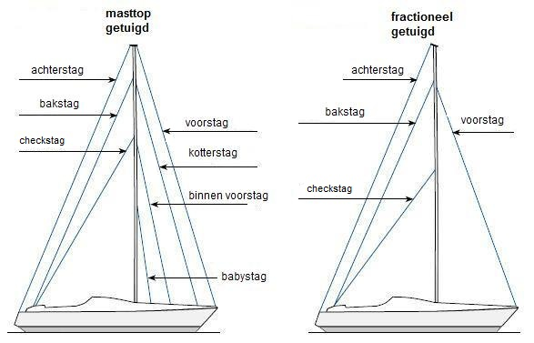
Afbeelding 5 Topgetuigd en fractioneel getuigd > de onderdelen van de verstaging

Want (lateraal)
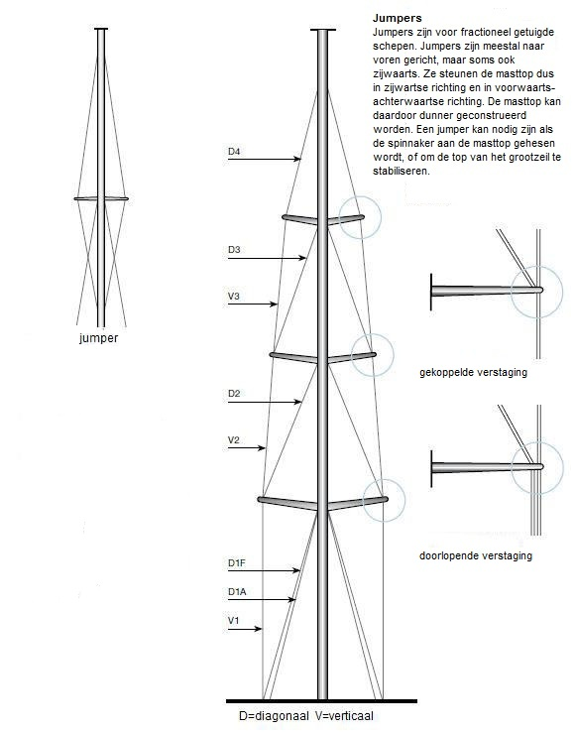
Afbeelding 6 Benamingen

Topwant: (V1-V3, D4) Staagt de mast tegen laterale (zijwaartse) belasting. Op topgetuigde boten bevestigd vlakbij de masttop, op fractioneel getuigde boten vlakbij de bevestiging van het voorstag. Het topwant wordt via zalingen naar de wantputtings geleid.

Jumper stag (“jumper”): Permanente verstaging voor een lange masttop van een mast die fractioneel getuigd is (Afbeelding 6).

Diagonaal tussenwant: (D2-D3) alleen bij masten met meer dan één stel zalingen. Bevestigd aan de einden van de onderste zalingen, doorlopend naar het dek, over de einden van de onderste zalingen. Het diagonale tussenwant beperkt de zijwaartse beweging van de mast daar waar de bovenste zalingen zitten.

Diagonaal onderwant: Bevestigd in de buurt van de onderste zalingen. Ze verstagen de plek van de zalingen. Vaak is er een onderwant naar voren (D1F) en een onderwant naar achteren (D1A). Ze stabiliseren de mast in voorwaartse en achterwaartse richting, en controleren de buiging van de mast.

Lopend want
 | Vallen: Lijn, of een combinatie van lijn en staaldraad, voor het hijsen van zeilen. Seldén gebruikt voor vallen de volgende kleuren:
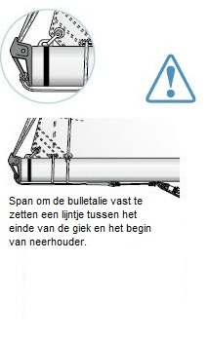 | • Genuaval: Blauw  • Grootzeilval: Wit  • Spinnakerval: Rood  Voorkom een te grote spanning op de genuaval.  Het voorstag moet op de juiste spanning gezet worden, elke keer als de zeilen gehesen worden. Daarom moet u het achterstag op spanning zetten, en eventuele bakstagen, voordat u het voorlijk van de genua op spanning zet. Als het zeil stevig gehesen wordt voordat het voorstag op spanning staat, komt er te veel spanning op de val te staan, op de halyard swivel (if a jib furling system is used) en op het zeil.  Grootzeilschoot: Talie voor het aantrekken van het grootzeil. Bevestigd aan het einde van de giek (end-sheeting) of verder naar voren op de giek (centre-sheeting). De onderkant van de grootzeilschoot is meestal bevestigd aan een wagen (traveller) die over de overloop loopt. De plek van de wagen op de overloop hangt af van hoe u het zeil wilt trimmen.
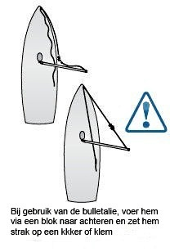 | Genua/fokkeschoot: Lijn voor het schoten van het voorzijl. Loopt via dekblokken naar lieren. De plaats van de dekblokken kan voorwaarts en achterwaarts gewijzigd worden, waarmee het zeil getrimd wordt.  Bulletalie: Lijn die gebruikt wordt voor het voorkomen van een ongewenste gijp. Bevestigd aan het achtereinde van de giek, en naar voren lopend naar een kikker, of via een blok op het voordek vastgezet in de kuip. De bulletalie moet niet vastgemaakt worden aan het midden van de giek, omdat dat schade kan veroorzaken. Vooral als de achterkant van de giek het water raakt bij het rollen van de boot.  Onderlijkstrekker: voor het op spanning brengen van het onderlijk.

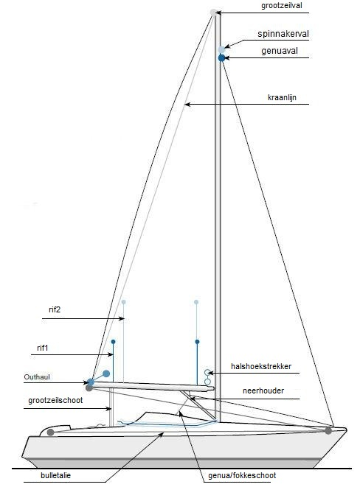

Reeflijnen: voor het reven van het grootzeil.
In Seldén’s eenlijns reefsysteem, worden het voorlijk en het achterlijk gereefd door dezelfde lijn. Seldén gebruikt de kleuren
• Rif 1: blauw
• Rif 2: rood

Halshoekstrekker (Cunningham): Lijn voor het onder spanning zetten van het voorlijk van het grootzeil.

Kraanlijn: Lijn, bevestigd aan het achtereinde van de giek, zorgt ervoor dat de giek niet op de kajuit valt op de momenten dat het zeil niet gehesen is, of tijdens het reven.

Neerhouder : voorkomt dat de giek omhoog gaat bij het voor de wind varen. Maakt het grootzeil vlakker en vermindert twist. Vaak gecombineerd met een ophouder (Selden Rodkicker), die de functie van de kraanlijn overneemt.

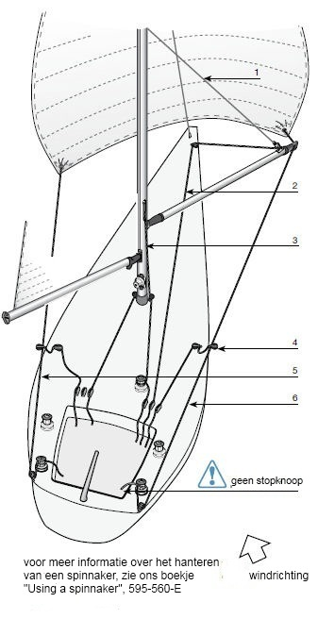 | (1)Lift: voor het horizontaal houden van de spinnaker boom. Bevestigd aan het einde van de boom, loopt via een blok op de mast naar het dek.  Downhaul: Used to set the horizontal position of the spinnaker pole in conjunction with the lift. Sometimes attached via a bridle. (2)  Pole heel lift: Line for adjusting the height of the spinnaker traveller on its track for trimming purposes. Also used for a vertical spinnaker pole stowage (VPS). (3)  Barber hauler: Line fitted to a block which runs amidships on the spinnaker sheet. Used in heavy weather to reduce the risk of the  spinnaker oscillating. (4)  Spinnaker sheet: Line for sheeting the spinnaker clew (on the leeward side). Led to winches via snatchblocks on the quarters. Required length is 2 x boat length. (5)  Spinnaker guy: Windward spinnaker sheet (6)

Voorbereiden voor plaatsen mast
Let op de volgende punten voordat u de boot naar de kraan laat rijden.  - Pak al het gereedschap dat u nodig heeft bij het plaatsen van de mast  - Maak alle spanners schoon en olie de schroefdraad.  - Rigging screws with the upper thread swaged onto the wire (stud rigging screws) are threaded for extension by twisting the body clockwise. Fit this type of rigging screws to the standing rigging.  - Fit all other rigging screws to the yacht’s chain plates with the left-hand thread downwards. Extend the rigging screws to the maximum extension by twisting the body clockwise. Ensure that the clevis pin at the upper end of the rigging screw can be removed quickly. All rigging screws will now operate in the same direction, and it will be easier to attach the shrouds and stays. | 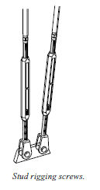
- Fit backstay adjuster.  The fork-ended rigging screw shown right may only be used if the chainplate is angled correctly and the rigging screw able to align with the stay. If not, a toggle must be inserted or a rigging screw with a toggled fork used. | 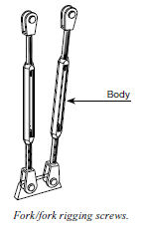

Controleren van de mast
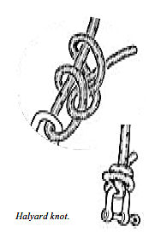 | New mast being rigged for the first time  • Establish the centre of gravity of the mast by laying the mast on a trestle like a seesaw. Mark the centre of gravity with a piece of tape on the forward side of the mast. You will use this mark later when positioning the lifting strop. Normally 60% of the mast height will do.  Marking the halyards. It is important to mark the halyards to indicate when the sail is fully hoisted. This prevents the splice jamming in the halyard box/head box, damaging the sheave. Jamming will not occur if the halyard shackle is fixed by a knot. All new rope halyards will get a certain permanent  elongation after the initial load. Make a temporary mark with a waterproof felt-tip pen. After some time sailing, check the marking and make it permanent using whipping twine. Using this mark together with trimming tape (a self-adhesive strip with graduated markings) on the mast or in the cockpit, assists consistent halyard trimming.  Genoa halyard and jib halyard. Set the halyard shackle so that the splice or knot is just clear of the masthead sheave. Attach a length of inelastic line to provide resistance. Put a load on the halyard equal to the normal extension with the foresail, and mark the halyard at a suitable place, such as the top edge of the winch plate or where it emerges from the slot fitting or forward of the stopper in the cockpit.  Main halyard. Locate the main halyard shackle so that the head of the mainsail will reach the lower edge of the calibration mark. Then proceed as above.

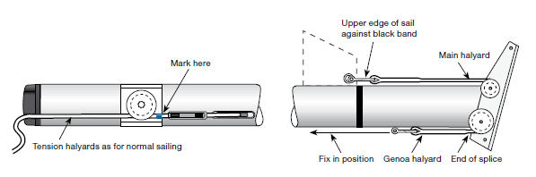

Voorbereiden van topwant en tussenwant

Attach the cap shrouds to the mast. Extend them along the mast, and check that they are the same length. If they are not, mark the difference on a piece of tape and attach
the tape to one of the shrouds (e.g. “+ 7 mm”). You can compensate for the difference using the rigging screws.
Attach the intermediate shrouds to the mast and lay these and the cap shrouds along the mast.
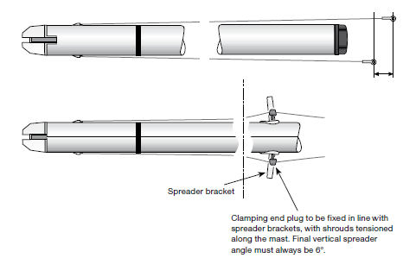

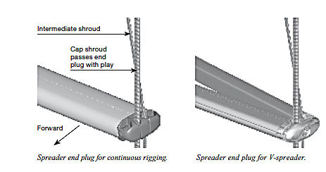

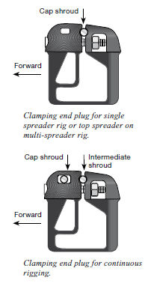 | Clamping end plugs  - This is the type of spreader end used for single-spreader rigs or on multi-spreader rigs when the intermediate shroud continues on beyond the spreader tip and down towards the yacht, “continuous rigging”.  - Locate the spreader end plugs on the cap shroud and intermediate shrouds, immediately in line with the spreader brackets with the shrouds tensioned along the mast. Correct location depends on spreader length, but the final vertical spreader angle must always be 6°.  - The lower spreader end on a multi-spreader rig clamps around the intermediate shroud, whereas the cap shroud passes the end plug with some play.  - Connect the lower shrouds to the spreader brackets or to their tangs.  - Connect the spreaders to the mast.  - Fit the spreader end plugs into the spreaders. Tighten the vertical locking screw hard to fix the plug in the spreader. Tighten the horizontal locking screws hard. The spreader ends must never, under any circum-stances, be allowed to slide on the shrouds. When themast has been stepped, it must be possible to stand on the spreaders without the ends sliding.

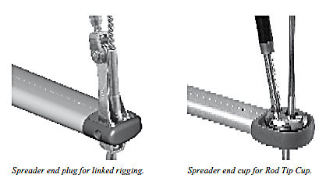

Onder de kraan
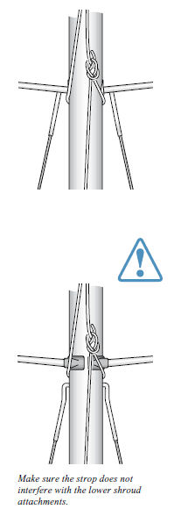 | This is an operation which requires considerable care and concentration. A botched crane lift causes material damage at best, but there is a clear risk of personal injury through carelessness. Adopt the following measures:  - Locating the yacht. Moor the yacht so that it is stationary under the crane, with the lifting hook centred immediately forward of the T-base or deck ring.  - External conditions. Avoid stepping a mast in a strong wind. Ensure that onlookers are at least a mast-length away.  - Manning. The absolute minimum is three people. One person is appointed “captain” to take charge of the work. The captain’s task is to guide the mast over the yacht, and he/she will not let go of the lower end of the mast until it is stayed (for keel-stepped masts, please see page 23). Another person operates the crane, on the directions of the captain. A third person assists the captain when the mast is being lifted and swung out over the yacht. When the mast is placed on the T-base, this person attaches the shrouds and stays. Later in the book, we give a description of the order in which this is to be done for different rig types.  - Place the mast below the crane with the luff-groove facing downwards and top of mast facing out.  - Locating the lifting strop. Locate the lifting strop close to or above the mast’s centre of gravity. If the strop is placed too far down, the mast will be “top-heavy”, which would cause a serious imbalance and make it difficult to hold the foot of the mast. Secure the strop with a strong rope carefully tied to a suitable fitting lower down the mast. For single-spreader rigs the strop is normally located underneath the spreader brackets. Make sure the strop does not interfere with the lower shroud attachments.

- The hook should be fitted with a locking device to prevent the lifting strop from slipping off. If this is not done, the strop must be fixed to the hook as shown in illustration on right.  - The lifting strop should be made from suitable rope, using a sheet bend. Check that all shrouds and stays are outside the strop. For multi-spreader rigs, if the strop is made long enough it will be possible to detach it from the hook after the mast has been stepped, without having to climb the first spreaders. However, make sure the crane is high enough to handle a long strop.  - A keel-stepped mast must be lifted high enough to be lowered straight down through the deck ring. Make sure the crane has sufficient vertical lift.  - When the mast has been stayed, move away from themast crane as soon as possible to make room for the next yacht  Tip  - Pad the hook and the hook attachment with soft rags or foam rubber before raising the mast. This prevents damage to the mast.  - Attach a line to the lifting strop to make it easier topull the strop down. | 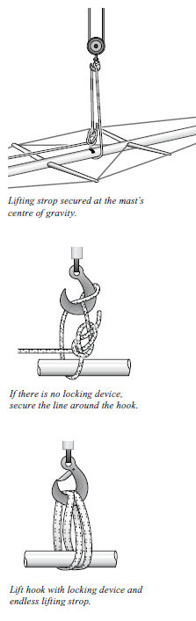

Doorlopende masten
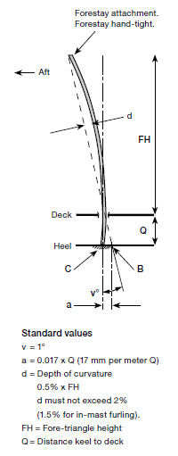 | The location of the heel for rake and  pre-bend of keel-stepped mast  A keel-stepped mast must take up an even curvature (convex  forward) right down to the mast heel. This means that the  mast heel must be located aft of a line from the forestay  attachment on the mast through the centre of the deck ring  (dashed line). Before you raise the mast, it is difficult to  decide precisely where the mast heel should go. Start  from the guide position as described below. The location  of the mast heel can usually be adjusted later.  Standard configuration: Selden calculates the standard  hand-tightened forestay length for a 1° aft rake. The normal  location of the heel is vertically below the centre of the  deck ring which makes for 0.5% pre-bend. You can adjust  both mast rake and pre-bend to suit your own ideas, based  on the following principles.  The length of the forestay determines the mast rake. For  1° rake aft and a straight mast, the heel must be located  0.017 x Q forward of the vertical line from the centre of  the deck ring. We call this point B. The mast must not,  however, be straight. It should have a certain amount of  pre-bend. 0.5% of the fore-triangle height is normal. To set  this amount of bend, the heel is located 0.017 x Q aft of  the B point. This is point C. The backstay is then tensioned  to 15% of its breaking load.
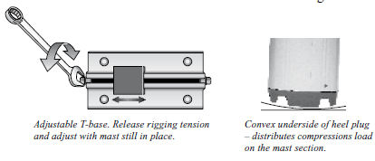

At the crane  - Lift up the mast and lower it carefully through the deck ring. To avoid damage to the mast, cloth or thick paper can be used as protection. One person must be below deck to handle the foot of the mast. Another person should be on deck and a third at the crane. The person on deck feeds the mast through the deck ring and will relay instructions from the person below decks to the crane driver.  - Lower the mast onto the T-base. Ensure the heel is securely located fore-and-aft and in-line.  - Attach the shrouds, forestay and backstay. Tighten them by hand until the mast is held fairly steady in the deck ring.  - Take off the lifting strop and leave the crane.  - Insert the aft rubber mast wedges and lubricate the forward fixing wedge with soapy water. Tighten the nut of the forward fixing wedge in the deck ring, so that the mast is held securely.  - Unless a permanent Tie-rod arrangement is installed as a structural part of the boat, attach Selden Tie-rod fittings, one at each side of the mast. Connect their lower parts to the mast and the bolts through the deck ring.  - Tune the standing rigging in the same way as for the equivalent deck-stepped rig.  - Tighten the Tie-rods just enough to prevent them from rattling.  - Fit the mast coat to the deck ring.  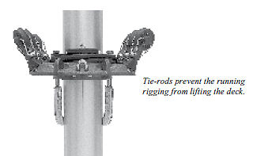 | 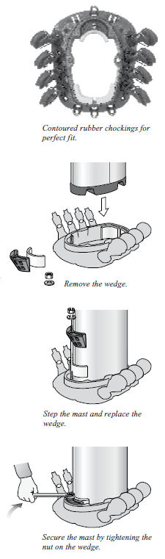

Deck ring assemblies for large masts
Mast sections: C321/171 F324/169
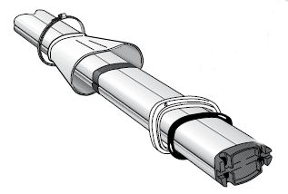
C365/194 F370/192
For these mast sections a two-piece deck ring assembly is used. The lower part is fitted to the deck, the upper part is supplied on the mast. A rubber o-ring is fitted between these parts. When the upper part is tightened to the lower, the o-ring compresses and secures the mast. Tie-rods are not incorporated in these deck rings as a permanent Tie-rod arrangement should always be provided by the boat builder.

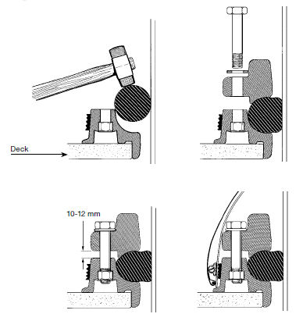

Tuning under sail  Lateral  - Due to the through-deck fit, it is not possible for a keelstepped mast to be straight throughout its length. So, while you are sailing, check that the mast takes a smooth curve from masthead to deck. If necessary, make adjustments using the lower shrouds and intermediate shrouds.  - Reef the sail and check for lateral tuning.  Longitudinal  - While sailing, check the fore-and-aft trim of the mast. Apart from the location of the mast foot, this is also affected by the backstay/forestay, inner forestay /checkstays, double lower shrouds or aft lower shroud + baby stay. The mast must have a slight positive pre-bend at the spreader area.  - For keel-stepped masts, it is important that the lower part of the mast makes a fair positive curve, not an S-shaped curve. Sight up the mast from deck level. It may be necessary to slacken the rigging, adjust the heel position on the T-base and reset the rigging.  - With an increasing load on the forestay, the masthead will want to move forwards, with the risk of a negative bend. This must be prevented. Even if the masthead in its original position is well aft, it is usually necessary to use some sort of backstay tensioner to counteract this movement.  - In other respects, the tuning is checked in the same way as for the corresponding deck-stepped rig type. | 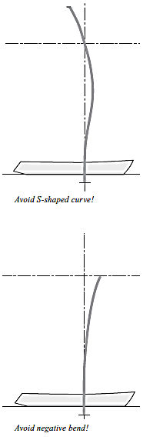

Alternative rigging of jib furling system
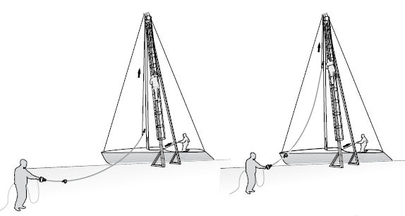
Normally, the jib furling system is placed on the forwardside of the mast when the mast is being lifted by the crane. One person is detailed to prevent the system damaging the mast or yacht. The extrusion used in the furling system can cope with large radius bends without any problems, but may break in the event of uncontrolled buckling.
If you feel that the jib furling system will be in the way during the mast lift, there is an alternative approach. This takes longer, but simplifies mast-stepping. It requires access
to a crane fitted with a ladder from which you can reach the forestay fitting on the mast. The installation can also be done from a bosun’s chair.
- Lay the furling system on the dock beside the crane.
- Step the mast without the jib furling system, and use the genoa halyard as a temporary forestay. The halyard is tied to the outermost (as seen from the dock) mooring cleat in the bows. Do not rely on key shackles or snap shackles.
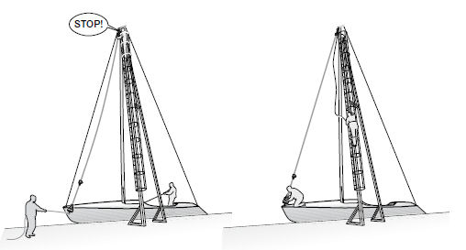
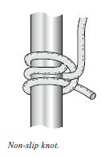
- Tighten the genoa halyard, and ease off the backstay/cap shroud to bring the forestay attachment fitting forward.
- Tie the spinnaker halyard to the top of the jib furling system using a non-slip knot, according to illustration.
- One person now climbs the ladder on the crane until the forestay attachment can be reached. Another person raises the jib furling system using the spinnaker halyard. A third person lifts the lower end of the jib furling system to prevent it dragging along the ground.
- The furler is attached to the mast, and the person aloft brings the spinnajer halyard down
- the The lower end of the system is attached to the forestay deck fitting.
- Cast off the genoa halyard and tighten the backstay/cap shrouds.

Spannen van het want

 | breeksterkte
Diameter in mm | kN | LBS
O 3 | 8 | 1,770
O 4 | 14 | 3,090
O 5 | 22 | 4,860
O 6 | 31 | 6,845
O 7 | 43 | 9,490
O 8 | 56 | 12,360
O 10 | 88 | 19,425
O 12 | 126 | 27,815
O 14 | 171 | 37,750
O 16 | 216 | 47,680
Het is essentieel voor alle soorten want dat het topwant de juiste spanning heeft. Het topwant wordt in de haven op spanning gezet, maar de fijnafstelling doet u tijdens het zeilen. De tabel hiernaast betreft staand want van 1 x 19 RVS draad. Dit is het meest gebruikte material voor stand want.
U moet voor want en stagen mikken op een spanning van 15-20% van de breeksterkte (the final check on tuning should be left until you are under sail). Then you know that the lateral staying is optimal both for the security of the rig and for sailing performance.
There are measuring instruments of greater or lesser reliability for this purpose on the market. Selden has developed a simple method of obtaining the information you need with material you probably already have. What you need to know is:
- All 1 x 19 stainless wire stretches under load, but returns to its original length when the load is removed. 1 mm stretch per 2 m wire is equivalent to 5% of the breaking load, irrespective of the diameter of the wire.
- A grp hull, on the other hand, changes its shape permanently when the rig is put under load. This makes it necessary to set up the rigging again after some time. This applies particularly to new yachts.
- At the dockside, both cap shrouds always have the same load. If you tension the starboard shroud, the port shroud is affected to precisely the same extent.

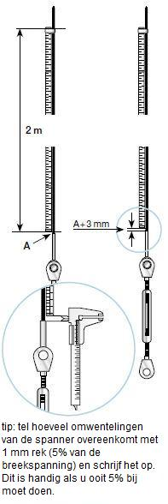
De “duimstok methode”
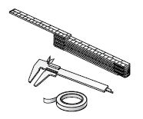
U hebt de volgende materialen nodig:
- Een 2 meter lange meetstok (een opvouwbare duimstok is het beste)
- Tape
- Vernier calipers
- Begin met het handvast aandraaien van de spanners. De mast wordt gestaagd door de lower shrouds and the forestay and backstay.
- Zet de bovenkant van de duimstok met tape vast op het stuurboord stag. De onderkant van de duimstok moet ongeveer 5 mm boven de bovenkant van de draadspanner eindigen. Meet de afstand tussen de draadspanner en de duimstok nauwkeurig. Dit is stand nu, we noemen het punt A.
- Span Tension the starboard cap shroud until the distance is A + 1.5 mm between the terminal and the folding rule. Measure using the vernier callipers.
- Leave the folding rule attached to the starboard shroud, and move across to the port side and tension the shroud rigging screw the equivalent amount.
- At intervals, check the starboard side to see how much the folding rule has moved from the end terminal. When there is a gap of A + 3 mm, the cap shrouds are tensioned to 15% of the breaking load of the wire (3 x 5% = 15%).

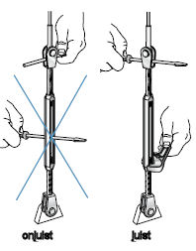
If the mast is not straight, adjust the lower shrouds, intermediate shrouds etc. There is more information on this in the chapter dealing with your rig type.

The folding rule method can be used on other stays, such as the backstay and forestay (without jib furling system). It can also be used for Dyform- or rod rigging, but please take the difference in stretch into account compared to 1 x 19 wire.

Rek per 2 meter
 | 1x19 wire | Dyform | Rod
5 % van de breeksterkte | 1 mm | 0,95 mm | 0,7 mm

Trimmen voor veiligheid
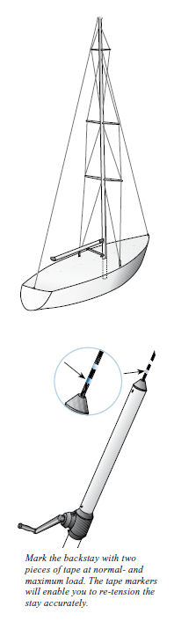
The rig is tuned for two reasons. Safety and speed. There are fundamental rules governing rig safety which apply to all rig types. Others are specific to fractional and masthead rigs respectively.

Factors which have a positive effect on mast stability:

Lateral
- Correct adjustment of the lateral rigging. The aim is to achieve a straight mast in the lateral plane during sailing. A keel-stepped mast, however, must have an even curve.

Longitudinal
- Fractional rig: A tight (not necessarily tensioned) backstay reduces the risk of the mast inverting. Inversion means that the mast creates a negative bend (the spreader area moving aft) until the mast buckles backwards. When the spreader area tries to move aft, the masthead wants to move forward, but this movement is prevented by a tight backstay.
- Masthead rig: Correctly tuned babystay or forward lower shrouds creating a positive pre-bend of the mast. This prevents inversion even if the backstay is slackened.

In addition ...
- Een stijve romp die zich verzet tegen vervorming. This prevents the tension in shrouds and stays being “wasted” in hull deformation.

Factoren met een negatieve invloed op de stabiliteit van de mast | Actie
1. Lateral rigging adjusted incorrectly. The most common fault is that the rigging is not tight enough | Adjust the lateral rigging in accordance with the instructions before leaving the dockside, and then check under sail.
2. Excessive mast bend. It must not exceed 2% of the height of the fore-triangle. For in-mast furling, the limit is 1.5%. | Reduce bend by easing off the backstay and/or tension checkstays. Pre-bend is adjusted by the interplay between the baby stay and the aft lower shroud or the forward/aft lower shrouds. On keel-stepped masts, the fore-and-aft location of the mast heel can be adjusted.
3. Sailing or motoring in high seas. The mast is subject to acceleration and deceleration forces in the foreand-aft direction, “pitching”. | These forces are caused by the weight and movement of the mast. Damage is avoided if the rigging is adjusted to prevent movement of the mast. This reduces dynamic stresses on the whole rig.
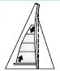  4. Reefing the mainsail until the headboard is considerably below the forestay fitting. There is a risk that the mast will take on a negative bend | Give the mast a positive pre-bend by adjusting the backstay, baby stay/forward lower stay and any inner forestay.
5. Pressure from the spinnaker pole on a broad reach (the spinnaker pole is close to the forestay). | The mast pre-bend is important. Adjust the fore lower shroud or baby stay so that these counteract the aftacting pressure from the spinnaker pole.
6. Pressure from the spinnaker pole if it hits the water during heavy rolling when running. | • Alter the lead of the spinnaker sheet using a barber hauler to prevent the spinnaker oscillating.  • Tighten the spinnaker pole lift  • Take in the spinnaker.
7. Fractional rig: Runners in combination with aft-swept spreaders. When a runner is tightened, it pulls themast aft and to windward. Forestay tension increases,and it stretches accordingly. Lateral rigging tension and tuning will be affected. This increases the risk of the mast buckling aft (inverting). | Adjust the lateral rigging in accordance with the instructions before leaving the dockside, tension the backstay, and then check under sail.
8. Hull not stiff enough. The rigging wire itself has negligible permanent deformation after loading. If, however,the hull gives too much under the rigging loads, tuning will be altered. All hulls, irrespective of construction material, will have more or less elastic deformations under load. GRP hulls take on a permanent deformation after a certain time under load. | There is not much you can do about it, other than be aware that it happens and check the tuning regularly.

Masthead rigs

14.1 Eén stel zalingen in lijn, mast op dek, single aft lower shrouds and baby stay
(Masthead rig with one set of swept spreaders and single aft lower shrouds and baby stay, is tuned with the same method)
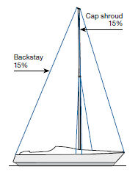
At the crane
- Read the ”At the crane” section on pages 18-19.
- Lift the mast and place it on the T-base.
- Attach the cap shrouds, backstay and forestay.
- Tighten the cap shrouds, forestay and backstay hand-tight so that the mast is stayed both laterally and longitudinally.
- Lower the lifting strop and attach the lower shrouds and baby stay. Hand-tighten and move the yacht away from the crane

Tuning
- Check the mast rake. If necessary, adjust using toggles on the forestay.
- Tension the cap shrouds to 15% of the breaking load of the wire. See the “folding rule method”, page 29.
- Straighten the mast using the lower shrouds. If necessary, adjust the rigging screws for the cap shrouds without changing the cap shrouds tension (slacken one rigging screw by exactly the same amount as you tighten the other one). Check that the mast is straight by sighting up the luff groove, all the way up from deck level.
- Give the mast a slight positive pre-bend by tightening the baby stay.
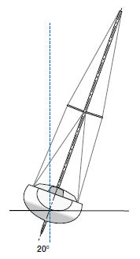
- Tension the backstay to 15% of the breaking load of the wire. Over a short period (a few hours) the load may be increased, but not to more than 30% of the breaking load of the wire. To achieve this loading, you will need a backstay tensioner. Make two marks on this so that you know when the normal (15%) and maximum (30%) loads have been reached. Use the “folding rule method” to find the correct setting. Since the backstay makes a wider angle with the mast, the forestay load will be about 40% of the breaking load of the wire when you put the “maximum load” on the backstay.

Tuning under sail
- Sail the yacht and check that the cap shrouds do not begin to slacken until about a 20° angle of heel is reached.
- While sailing, check that the mast is straight laterally. Adjust if necessary using the lower shrouds.
- Reef the sail and check for lateral straightness. If the deviation from the straight line is greater than 5 mm, the lower shrouds must be adjusted.
- While sailing, check the longitudinal trim of the mast. The mast must have a slight positive bend at the spreader area. Sight up the mast from deck level. With an increasing load on the forestay, the masthead will want to move forward, with the risk of a negative bend. This must be prevented. Even if the masthead in its original position is well aft, it is usually necessary to use some sort of backstay tensioner to counteract this movement.
- When you are satisfied with the tuning, lock the rigging screws.
- A new rig on a new yacht will need adjusting after sailing for some time. When the tuning at the end of the first season is satisfactory, mark the setting on the rigging screws. Enter your figures on page 80. This makes it easy to tune the rig at the start of the next season.

Eén stel zalingen in lijn, mast op dek, forward and aft lower shrouds
(Masthead rig with one set of swept spreaders and forward and aft lower shrouds, is tuned with the same method)

At the crane
- Read the “At the crane” section on pages 18-19
- Lift the mast and place it on the T-base.
- Attach the cap shrouds, backstay and forestay.
- Tighten the cap shrouds, forestay and backstay hand-tight so that the mast is stayed both laterally and longitudinally.
- Lower the lifting strop and attach the lower shrouds.
- Hand-tighten and move the yacht away from the crane.

Tuning
- Check the mast rake. If necessary, adjust using toggles on the forestay.
- Tension the cap shrouds to 15% of the breaking load of the wire. See the “folding rule method”, page 29.
- Straighten the mast using the forward lower shrouds. If necessary, adjust the rigging screws for the cap shrouds without changing the cap shrouds tension (slacken one rigging screw by exactly the same amount as you tighten the other one). Check that the mast is straight by sighting up the luff groove, all the way up from deck level.
- Give the mast a slight positive pre-bend using the interplay between the forward and aft lower shrouds. The job of the aft lower shrouds is to reduce the pre-bend to the amount originally determined.
- Tension the backstay to 15% of the breaking load of the wire. Over a short period (a few hours) the load may be increased, but not to more than 30% of the breaking load of the wire. To achieve this loading, you will need a backstay tensioner. Make two marks on this so that you know when the normal (15%) and maximum (30%) loads have been reached. Use the “folding rule method” to find the correct setting. Since the backstay makes a wider angle with the mast, the forestay load will be about 40% of the breaking load of the wire when you put the “maximum load” on the backstay.

Tuning under sail
- Sail the yacht and check that the cap shrouds do not begin to slacken until about a 20° angle of heel is reached.
- While sailing, check that the mast is straight laterally. Adjust if necessary using the forward lower shrouds.
- Reef the sail and check for lateral straightness. If the deviation from the straight line is greater than 5 mm, the lower shrouds must be adjusted.
- While sailing, check the longitudinal trim of the mast. The mast must have a slight positive bend at the spreader area. Sight up the mast from deck level. With an increasing load on the forestay, the masthead will want to move forward, with the risk of a negative bend. This must be prevented. Even if the masthead in its original position is well aft, it is usually necessary to use some sort of backstay tensioner to counteract this movement.
- When you are satisfied with the tuning, lock the rigging screws.
- A new rig on a new yacht will need adjusting after sailing for some time. When the tuning at the end of the first season is satisfactory, mark the setting on the rigging screws. Enter your figures on page 80. This makes it easy to tune the rig at the start of the next season.

14.3 Masttop getuigd, meerdere gepijlde zalingen, mast op dek, forward and aft lower shrouds. Alternatively baby stay and aft lower shrouds.
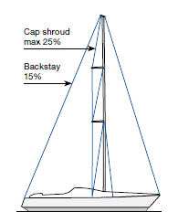
This type of rig is very demanding on the sailor, since it is complex to tune and to handle. In general, this type of rig needs more tension in the shrouds than a rig with in-line spreaders.

At the crane
- Read the “At the crane” section on pages 20-21.
- Lift the mast and place it on the T-base.
- Attach the cap shrouds, backstay, forestay and lower shrouds.
- Tighten the cap shrouds, forestay and backstay hand-tight so that the mast is stayed both laterally and longitudinally.
- Lower and remove the lifting strop. Move the yacht away from the crane.

Tuning
- Check the mast rake. Adjust if necessary using toggles on the forestay.
- Tension the backstay to 15% of the breaking load of thewire. This puts the forestay under tension corresponding to about 20% of its breaking load. Since the backstay makes a wider angle with the mast, the forestay load will be greater. Make a mark on your backstay tensioner so that you will always know when normal load (15%) has been achieved. Use the “folding rule method”, see page 29, to find the correct setting. Leave the folding rule on the backstay.
- Tension the cap shrouds to 15% of the breaking load of the wire. See the “folding rule method”. Count and make a note of the number of turns on both the port and starboard rigging screws required to increase the tension by 5% (1 mm stretch). Leave the folding rule on the shroud.
- Roughly straighten the mast using the lower and intermediate shrouds. Note that the intermediate shroud tension should be fairly low at this stage, only sufficient to keep the mast straight. Check that the mast is straight by sighting up the luff groove, all the way up from deck level.
- Increase backstay tension to 20% of its breaking load. Mark the setting on the backstay tensioner at this pretension level as well. The cap shrouds tension has now been reduced since the masthead has been pulled downwards/aft by the backstay.
- Increase the cap shrouds tension to 20% of the breaking load of the wire.
- Tune the mast straight again using the lower shrouds and the intermediate shrouds.
- Slacken the backstay to 15% of its breaking load, in other words, to the first mark.
- Now check the cap shrouds tension. It should not exceed 25% of the breaking load of the wire.
- On this type of rig, forestay tension is affected by both backstay and cap shrouds. With 20% of the breaking load in the backstay and cap shrouds respectively, the load on the forestay is about 40% of the breaking load.

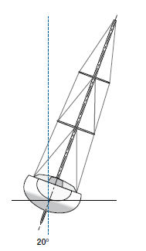
Tuning under sail
- At about a 20° angle of heel and maximum pre-tension on the backstay, the lee cap shroud must not be slack. If it is, increase the pre-tension, but not to more than 25% of the breaking load of the wire (the same number of turns on the rigging screws as per your previous note).
- Tune the mast straight laterally using the lower shrouds and the intermediate shrouds.
- Reef the sail and check that the mast is straight laterally. If it deviates from the straight by more than 5 mm, the lower shrouds must be adjusted.
- While sailing, check the mast’s fore-and-aft tuning. The mast should have a slight forward bend at the spreader area. Sight along the mast from deck level. Adjust if necessary using the lower shrouds.
- Check the tune for different backstay tensions and different sail combinations (reef).

To ensure good fore-and-aft stability for this type of rig, it is very important that the leeward cap shroud is tight. This high level of pre-tension will generate plastic deformation on all grp hulls. As far as strength is concerned, the hull should be able to support these loads, but the deformation will make it necessary to check the tuning while sailing. This is particularly important when the yacht is new and at the start of every season.

14.4 Masttop getuigd, meerdere zalingen in lijn, mast op dek, forward and aft lower shrouds. Alternatively, baby stay and aft lower shrouds.
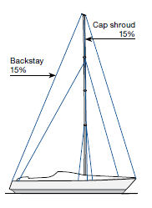
This type of rig is often fitted with an inner sail-carrying forestay, a cutter stay. The location of the cutter stay determines whether “running backstays” (also called “runners”) are needed to provide sufficient longitudinal stability as well as to provide the necessary cutter stay tension. We recommend runners if the cutter stay is attached more than 6% of the fore-triangle height below the ordinary forestay fitting.

At the crane
- Read the “At the crane” section on pages 20-21
- Lift the mast and place it on the T-base.
- Attach the cap shrouds, backstay, forestay and all four lower shrouds.
- Tighten the cap shrouds, forestay and backstay hand-tight so that the mast is stayed both laterally and longitudinally. Attach the lower shrouds.
- Lower and remove the lifting strop. Move the yacht away from the crane.

Tuning
- Check the mast rake. Adjust if necessary using toggles on the forestay.
- Tension the cap shrouds to 15% of the breaking load of the wire. See the “folding rule method”, page 29.
- Straighten the mast using the forward lower shrouds and the intermediate shrouds. If necessary, adjust the rigging screws for the cap shrouds without changing the cap shrouds tension (slacken one rigging screw by exactly the same amount as you tighten the other one). Check that the mast is straight by sighting up the luff groove, all the way up from deck level.
- Give the mast a slight positive pre-bend using the interplay between the forward and aft lower shrouds. The job of the aft lower shrouds is to reduce the bend to the amount originally determined.
- Tension the backstay to 15% of the breaking load of the wire. Over a short period (a few hours) the load may be increased, but not to more than 30% of the breaking load of the wire. To achieve this loading, you will need a backstay tensioner. Make two marks on this so that you know when the normal (15%) and maximum (30%) loads have been reached. Use the “folding rule method” to find the correct setting. Since the backstay makes a wider angle with the mast, the forestay load will be about 40% of the breaking load of the wire when you put the “maximum load” on the backstay.

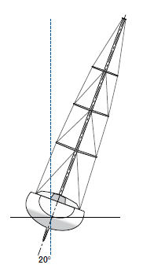
Tuning under sail
- Sail the yacht and check that the cap shrouds do not begin to slacken until about a 20° angle of heel.
- While sailing, check that the mast is straight laterally. Adjust this if necessary using the forward lower shrouds and intermediate shrouds.
- Reef the sail and check the mast for lateral straightness. If the deviation from the straight line is greater than 5 mm, the lower shrouds or the intermediate shrouds must be adjusted.
- While sailing, check the longitudinal trim of the mast. The mast must have a slight positive bend at the spreader area. Sight up the mast from deck level. Adjust if necessary by tuning the interplay between the aft- and forward lower shrouds or cutter stay/runner. With an increasing load on the forestay, the masthead will want to move forwards, with the risk of a negative bend. This must be prevented. Even if the masthead in its original position is well aft, it is usually necessary to use some sort of backstay tensioner to counteract this movement.
- When you are satisfied with the tuning, lock the rigging screws.
- A new rig on a new yacht will need adjusting after sailing for some time. When the tuning at the end of the first season is satisfactory, mark the setting on the rigging screws. Enter your figures on page 80. This makes it easy to tune the rig at the start of the next season.

Cutter stay and runners
A cutter stay in combination with runners also affects the forward bend of the mast. Runners are tensioned with winches and/or tackles to a maximum of 30% of their breaking load.

14.5 Fractioneel getuigd, één stel gepijlde zalingen, single aft lower shrouds, mast op dek
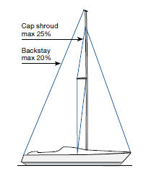
In general, this type of rig needs more tension in the shrouds than a rig with in-line spreaders. The tension in the forestay is affected by three components;
- The cap shrouds
- The backstay
- The sheeting of the mainsail

At the crane
- Read the “At the crane” section on pages 20-21.
- Lift the mast and place it on the T-base.
- Attach the cap shrouds, backstay, and forestay.
- Tighten the cap shrouds, forestay and backstay temporarily so that the mast is stayed both laterally and longitudinally.
- Lower the lifting strop and remove it. Attach the lower shrouds. Move the yacht away from the crane.
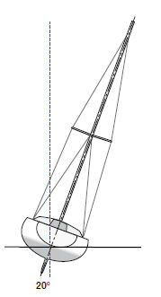
Tuning
- Check the mast rake. Adjust if necessary using toggles on the forestay.
- Tension the cap shrouds to 15% of the breaking load of the wire. See the “folding rule method”, page 29. Leave the folding rule on the shroud.
- Roughly straighten the mast using the lower shrouds. Check that the mast is straight by sighting up the luff groove, all the way up from deck level.
- Increase the cap shrouds tension to 20% of the breaking load of the wire. Count and make a note of the number of turns on both the port and starboard rigging screws required to increase the tension by 5% (1 mm stretch).
- Tune the mast straight again using the lower shrouds.
- Tension the backstay hard, but not exceeding 20% of the breaking load of the wire. Make a mark on your backstay tensioner or tackle so that you will always know when this normal load has been achieved. Use the “folding rule method” to find the correct setting. This will reduce the tension of the cap shrouds.
- Increase the cap shroud tension back to 20% of the breaking load of the wire.
- Slacken the backstay completely
- Now check the cap shrouds tension. It should not exceed 25% of the breaking load of the wire.

Tuning under sail
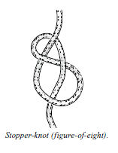
- At about a 20° angle of heel and maximum pre-tension (20%) on the backstay, the leeward cap shroud must not be slack. If it is, increase the shrouds pre-tension, but not to more than 25% of the breaking load of the wire (the same number of turns on the rigging screws as per your previous note).
- Tune the mast straight laterally using the lower shrouds.
- Check the tune for different backstay tensions and different sail combinations (reef).
- The backstay must not be allowed to completely slacken at any time. If the masthead is able to move forwards, the mast is in danger of buckling aft. If using a tackle, put a stopper-knot in the tail to limit the reduction in backstay tension.

To ensure good fore-and-aft stability for this type of rig, it is very important that the leeward cap shroud is tight. This high level of pre-tension will generate plastic deformation on all grp hulls. As far as strength is concerned, the hull should be able to support these loads, but the deformation will make it necessary to check the tuning
while sailing. This is particularly important when the yacht is new and at the start of every season.

14.6 Fractioneel getuigd, meerdere stellen gepijlde zalingen, mast op dek
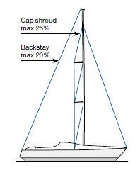
Dit type tuigage is voor de zeiler zeer veeleisend, omdat het lasting te trimmen en te hanteren is. In general, this type of rig needs more tension in the shrouds than a rig with in-line spreaders. The tension in the forestay is affected by three components;
1. The cap shrouds
2. The backstay
3. The sheeting of the mainsail

At the crane
- Read the “At the crane” section on pages 20-21.
- Lift the mast and place it on the T-base.
- Attach the cap shrouds, backstay, forestay and lower shrouds.
- Tighten the cap shrouds, forestay and backstay hand-tight so that the mast is stayed both laterally and longitudinally.
- Lower and remove the lifting strop. Move the yacht away from the crane.

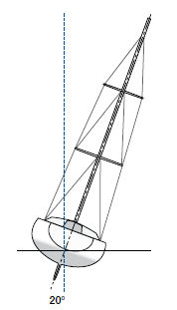
Tuning
- Check the mast rake. Adjust if necessary using toggles on the forestay.
- Tension the cap shrouds to 15% of the breaking load of the wire. See the “folding rule method”, page 29. Leave the folding rule on the shroud.
- Roughly straighten the mast using the lower and intermediate shrouds. Note that the intermediate shroud tension should be fairly low at this stage, only sufficient to keep the mast straight. Check that the mast is straight by sighting up the luff groove, all the way up from deck level.
- Increase the cap shrouds tension to 20% of the breaking load of the wire. Count and make a note of the numberof turns on both the port and starboard rigging screws required to increase the tension by 5% (1 mm stretch)
- Tune the mast straight again using the lower shrouds and the intermediate shrouds.
- Tension the backstay hard, but not exceeding 20% of the breaking load of the wire. Make a mark on your backstay tensioner so that you will always know when this normal load has been achieved. Use the “folding rule method” to find the correct setting. This will reduce the tension of the cap shrouds.
- Increase the cap shroud tension back to 20% of the breaking load of the wire.
- Slacken the backstay completely.
- Now check the cap shrouds tension. It should not exceed 25% of the breaking load of the wire.
Tuning under sail
- At about a 20° angle of heel and maximum pre-tension (20%), on the backstay, the leeward cap shroud must not be slack. If it is, increase the pre-tension, but not to more than 25% of the breaking load of the wire (the same number of turns on the rigging screws as per your previous note).
- Tune the mast straight laterally using the lower shrouds and the intermediate shrouds.
- Check the tune for different backstay tensions and different sail combinations (reef).
- The backstay must not be allowed to completely slacken at any time. If the masthead is able to move forwards, the mast is in danger of buckling aft. If using a tackle, put a stopper-knot in the tail to limit the reduction in backstay tension.

To ensure good fore-and-aft stability for this type of rig, it is very important that the leeward cap shroud is tight. This high level of pre-tension will generate plastic deformation on all grp hulls. As far as strength is concerned, the hull should be able to support these loads, but the deformation will make it necessary to check the tuning while sailing. This is particularly important when the yacht is new and at the start of every season.

14.7 Fractioneel getuigd, meerdere stellen zalingen in lijn, mast op dek, forward and aft lower shrouds. Alternatively baby stay and aft lower shrouds.
(Equivalent one-spreader rig is tuned in the same way)

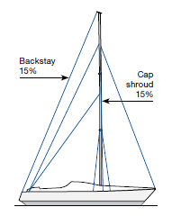
Runners are required to give sufficient longitudinal stability, and to obtain the required forestay tension. The backstays must be located as near the centre line of the hull as possible so as not to affect the lateral tuning. This type of rig is also found with single lower shrouds, in-line, and in that case checkstays are recommended to prevent excessive mast bend.

At the crane
- Read the “At the crane” section on pages 20-21.
- Lift the mast and place it on the T-base.
- Attach the cap shrouds, backstay, forestay and lower shrouds.
- Tighten the cap shrouds, forestay, backstay and lower shrouds hand-tight so that the mast is stayed both laterally and longitudinally.
- Lower and remove the lifting strop. Move the yacht away from the crane.

Tuning
- Tension both runners 15% of their breaking load.
- Check the mast rake. Adjust if necessary using toggles on the forestay.
- Tension the cap shrouds to 15% of the breaking load of the wire. See the “folding rule method”, page 29.
- Straighten the mast using the aft lower shrouds and the intermediate shrouds. If necessary, adjust the rigging screws for the cap shrouds without changing the capshrouds tension (slacken one rigging screw by exactly the same amount as you tighten the other one). Check that the mast is straight by sighting up the luff groove, all the way up from deck level.
- Tension the backstay 15% of its breaking load.
- Give, if necessary, the mast a slight positive bend using the interplay between the aft and forward lower shrouds. The job of the forward lower shrouds is to prevent the spreaders moving aft if there is little load on the backstay.

Tuning under sail
- Sail the yacht with backstay (15%) and windward runner set to 15-30% of its breaking load. Check that the cap shrouds do not begin to slacken until about a 20° angle of heel.
- While sailing, check that the stayed section of the mast is straight laterally. Adjust if necessary using the aft lower shrouds and intermediate shrouds. The unstayed bare upper section will bend to leeward under sail, and you cannot compensate for this.
- Reef the sail and check for lateral straightness. If the deviation from the straight line is greater than 5 mm, the lower shrouds and/or intermediate shrouds must be adjusted.
- While sailing, both with full and reefed main, check the longitudinal trim of the mast. The mast must have a slight positive bend at the spreader area. Sight up the aft side of the mast from deck level. Under no circumstances must the top of the mast be allowed to move forward. If it does, there is a risk of the mast buckling aft (inverting). The backstay and forward lower stays must always be sufficiently tensioned to counteract this. If using a tackle to tension the backstay, put a stopper-knot in the tail to limit the available tension reduction. The risk of buckling should be kept in mind when checkstays are used.
- When you are satisfied with the tuning, lock the rigging screws.
- A new rig on a new yacht will need adjusting after sailing for some time. When the tuning at the end of the first season is satisfactory, mark the setting on the rigging screws. This makes it easy to tune the rig at the start of the next season.
- Forestay tension is adjusted using the runners. The windward runner must always be tight. Very tight when beating. Mark your runner tackles at the positions which give the best trim on different points of sail.

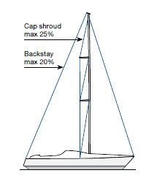
19/20 rig and similar
This is a fractional rig with a short distance between the masthead and the forestay fitting, which is a good compromise between the well-tensioned forestay of the masthead rig and the fractional rig’s flexible mast and easily-reefed, efficient mainsail. Runners are not required to obtain sufficient forestay tension. Making the right choice for the length of the unsupported mast in relation to the foretriangle height and longitudinal stiffness of the mast section gives an optimal mast bend both in hard winds (high forestay loads and considerable mast bend/f lat mainsail) and in light winds. The spreaders may be in-line or swept aft. The forestay tension and the mast bend/ mainsail fullness are varied through adjusting the backstay tension. The backstay must not be eased completely for the reasons given below.
At the crane
- Follow the instructions for the appropriate fractional rig

Tuning
- Follow the instructions for the appropriate fractional rig. For rigs fitted with double lower shrouds, tuning will be carried out using the aft lower shrouds when the forestay has been tensioned to the maximum permitted load. The aft lower shrouds affect both the lower part of the longitudinal mast curve (limit bend) and in-line tuning (straighten mast). The forward lower shrouds are tensioned only enough to prevent the mast buckling aft (inverting). This is particularly important when sailing in rough seas.

Tuning under sail
- Follow the instructions for the appropriate fractional rig.
- For rigs with single (aft) lower shrouds, it is absolutely vital never to let the masthead move forward creating a negative bend of the mast. The backstay must always be tensioned to prevent this. Without forward lower shrouds or a baby stay, there is nothing but the backstay, and possibly swept spreaders, to prevent the mast inverting. A mast which inverts usually suffers serious damage, and in the worst case, the rig may be lost.

If you are using a tackle to tension your backstay, put a stopper-knot in the tail to limit the reduction in backstay tension.

B & R tuigage (Bergström & Ridder) zonder bakstag
B & R characteristics:
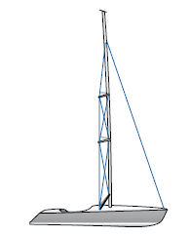
- De gepijlde zalingen staan onder een hoek van 30°, dat is nogal wat meer dan bij gewone rigs.
- Reverse diagonals (RD) are used to induce pre-bend compression, adding rigidity to the mast section. This negates the need for a baby stay or inner forestay.
- Runners and backstay are not usually fitted as the spreader sweep angle allows the cap shrouds to provide the necessary longitudinal support.
- Inner forestays and baby stays are never used.
- Sometimes fitted with fixed struts which stay the lower part of the mast.
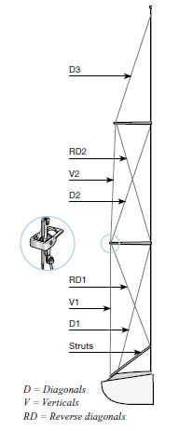
The absence of a backstay reduces the mast compression on this type of rig in comparison with conventional rigs. This, along with any fixed struts, means that the mast profile is often relatively small both athwartships and fore-and-aft. Advocates of the B & R rig maintain that its “better aerodynamics” make it suitable for racing, and the leisure sailor benefits from avoiding trimming the rig while sailing. The lack of backstay and runners means that there are no adjustments to be made at sea. The foredeck is free from baby stay and inner forestay, and this makes tacking easier. Most of the trimming of the rig must be done before the mast is stepped on the boat.

At the crane
- Lay the mast on two trestles. The sail track must face downwards. The trestles must be high enough to keep the spreader ends off the ground. All stays must be loose.
- Tighten the reverse diagonals to give the mast a positive pre-bend. Begin with RD1, then RD2. These shrouds interact, and, to provide an even curve, they must be tensioned by about the same amount.

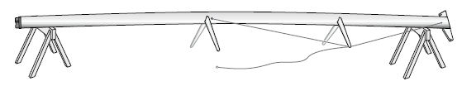
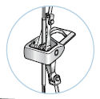
- The amount of a pre-bend depends on the cut of the mainsail. A general rule is that the pre-bend should be 1% of the distance from the masthead to the gooseneck, measured at the centre of this distance. The mast must have no lateral bend. All pre-bend must be in the fore- and aft direction.
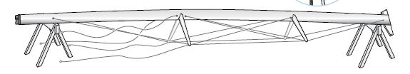

- Position the lifting strop between the spreader brackets, just above the point of balance, and hold down with a strong line. Make sure the forestay is not inside the strop. It is usually possible to make the eye long enough to enable it to be cast off without going up to the lower spreaders on a double spreader rig.
- Raise the mast, and place it on the T-base. Attach the cap shrouds but do not tighten them yet.
- Attach the forestay.
- Attach the lower shrouds.
- Hand-tighten the cap shrouds and forestay.
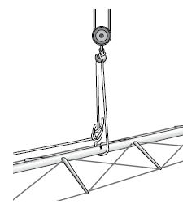
- Set the fore-and-aft mast rake by using the main halyard as a plumb line. Attach a weight to the halyard. The mast is normally either vertical or has a slight aft rake. The mast rake can be altered by adjusting the length of the forestay using the rigging screw or using toggles.
- Tension the forestay rigging screw, but not too much.
- Tension the cap shrouds to 20% of their breaking load. See the folding rule method, page 29. The pre-bend will now increase slightly.
- Lower and remove the lifting strop. Move the yacht away from the crane.

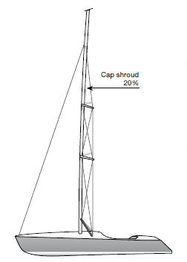
Tuning
- Check that the upper part of the mast is straight thwartships. Adjust if necessary using the intermediate shrouds. Slacken one side by the same amount you tighten on the other.
- Tension the lower shrouds to 20% of their breaking load. Check that the mast is straight athwartships. Adjust if necessary using the lower shrouds on the same principle as above. The mast should now have approximately the same pre-bend as it had when it was lying on the trestles, and it will be straight athwartships.
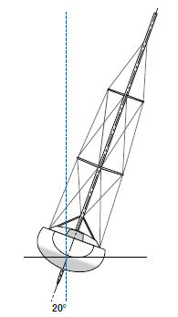
Tuning under sail
- Sail the boat at about a 20° angle of heel. The lee cap shroud and lower shroud must not be slack. If they do slacken, they must be tensioned so that the slack is halved. Then tack the boat and tighten the equivalent amount on the other shrouds, which are now on the lee side.
- Check that the mast is straight athwartships by sighting up the mast from deck level. Tension both sides by the same amount so that the mast is straight on both tacks.

When you have trimmed a B & R rig, you must document the setting of the rigging screws very carefully. Alternatively, store the mast for the winter with the spreaders mounted and the intermediate shrouds and reverse diagonals in tune

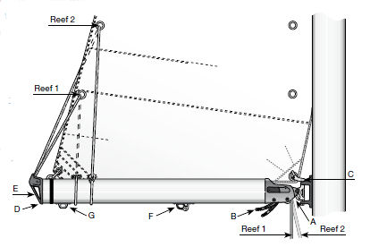
Gieken
Seldén’s booms are fitted with slab-reefing or single-line reefing, or are adapted for use with in-mast furling. The boom profiles are relatively deep in relation to their width. This gives a boom which is light in weight, and has a high resistance to vertical bending. The booms are fitted with stoppers at the gooseneck, if sail-handling is to be done forward at the mast. No stoppers are fitted if the lines are to be led back to the cockpit. For detailed information, please order our spare parts list, art no 595-081-E.

A. Gooseneck including sheaves for reef-lines and outhaul.
B. Spring-loaded rope clutches, colour code equivalent to rope.
Reef 1: Blue
Reef 2: Red….
Reef 3: Yellow
Reef 4: White
Outhaul: White
C. Reef hooks for slab-reefing.
D. Boom end, fitted with screws. Easy access for maintenance and line replacement.
E. Cast bracket for preventer guy. See page 10.
F. Kicker slider.
G. Main sheet slider.

17.1 Slab-reefing boom
Fitted with 1- 4 reefs and outhaul.
Reefing
- Ease the sheet and vang, then set up the topping lift.
- Ease the main halyard by just a little more than the height of the reef.
- Hook the luff cringle for the reef in one of the two reef hooks at the gooseneck.
- Tighten the halyard.
- Reef the leech by hauling in the reefing line using the reefing winch.
- Ease the topping lift, tighten the vang and haul in the sheet.

To shake out a reef
- Ease the sheet and vang, then set up the topping lift.
- Release the reefing line
- Ease the halyard slightly, unhook the luff cringle.
- Tighten the main halyard.
- Ease the topping lift, tighten the vang and haul in the sheet.

17.2 Single-line reefing
Fitted with two Single-line reefs and outhaul. A flattening reef is available on request. Through a system of blocks inside the boom, a single line pulls both luff and leech down to the boom. The block system has a 2:1 purchase. If the halyard and reefing line are led back to the cockpit, there is no need to go on deck to take a reef. Make two permanent markings on the halyard at the position for reef 1 and reef 2.
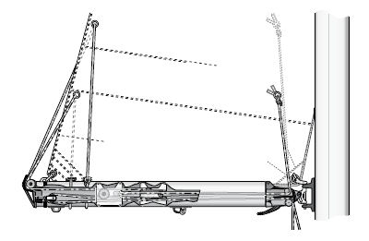
It is important to note that no fittings should be mounted on the sides of the booms. The space between the carriages for the running blocks and the sides of the boom is limited. Fastenings for external fittings could prevent the movement of the carriages.

Reefing
- Ease the sheet and vang, then set up the topping lift.
- Ease the main halyard to the first marking.
Afbeelding 7 We bevelen aan om een vaste neerhouder te gebruiken. Die zorgt ervoor dat de giek niet omlaag valt wanneer je bezig bent een rif te zetten. Als er een gasveer in zit kan hij de …. vervangen
- Haul in the reefing line so that both the luff and leech cringles are pulled down to the boom, and
- then take up the slack in the 2nd reef.
- Tighten the vang and haul in the sheet.

To shake out a reef
- Ease the sheet and vang.
- Release the reefing lines.
- Tighten the main halyard and then the sheet and vang.

17.3 In-mast furling (manual version)
The boom is fitted with an outhaul, and the mast with a linedriver winch which is operated by an endless furling line.
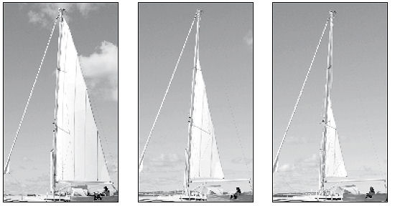

Reefing
We assume that the outhaul and furling line are led back to the cockpit, and that a rigid vang is fitted.
- Tighten the vang slightly to maintain tension in the leech.
- Slacken of the sheet.
- Ease off the outhaul about 0.5 meter (more or less, depending on how deep a reef you want to take in) and apply the stopper.
- Haul on the starboard part of the furling line until the outhaul is tight. Apply both stoppers.

To shake out a reef
- Adjust the vang to apply a moderate tension in the leech of the sail.
- Release the stoppers for the furling line to allow the sail to unfurl from inside the mast.
- Tighten the outhaul.

Neerhouder-ophouder
Rodkicker is Seldén’s rigid vang. It replaces the topping lift by preventing the boom falling into the cockpit during reefing. In addition, when fitted with a gas-spring, it lifts the end of the boom, and this opens the leech of the mainsail. A very useful trimming aid, in other words.
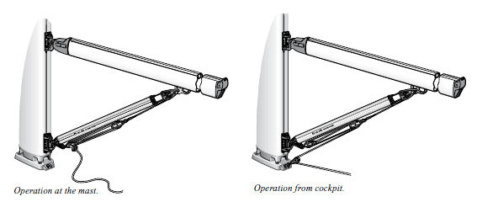

Fitting a Rodkicker
Detailed fitting instructions are included with every Rodkicker, but two points are of particular importance.
- Under no circumstances must the rigid vang be allowed to “bottom out” when the mainsail is sheeted fully. If it “bottoms” it generates a breaking force which can damage the boom.

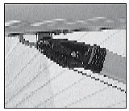
- Seldén’s booms are fitted with a kicker slider as standard. This runs in a groove on the underside of the boom. The slider is not fixed, since its correct position depends on the cut of the mainsail. When the correct position is established, the kicker slider is located permanently with three bolts, so that it will not slide in the groove. This is done by drilling clearance holes (holes 2 mm larger than the diameter of the bolt) in the boom. The bolts are threaded in the kicker slider for the whole of their length. In this way the kicker fastening is fixed when the bolts go into the holes.

Werken in de hoogte
Drie zaken zijn belangrijk bij werken ‘in de hoogte’
Hoisting a member of the crew up the mast is always a very risky operation. Be sure to proceed with great caution.
- Gebruik goed gereedschap en andere spullen
- Gebruik de juiste technieken
- Zorg voor bekwame en betrouwbare helpers

1. Gereedschap
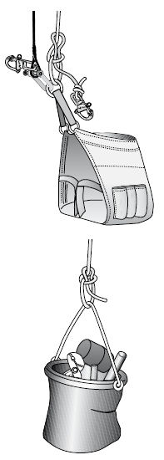
- Gebruik een professionele bootsmanstoel van goede kwaliteit, zo een die goed past rondom middel en benen
Afbeelding 8 Bootsmanstoel en canvas zak met gereedschap
- De vakken in een bootsmanstoel zijn vaak te nauw om praktisch te zijn. Plastic emmers zijn niet geschikt om gereedschap in mee te nemen, omdat ze gemakkelijk kantelen als ze ergens achter haken. U kunt gereedschap het beste meenemen in een canvas zak die u met een korte lijntje aan de stoel vastmaakt
- Neem een stuk touw mee, zodat u de bootsmanstoel kunt vastmaken aan de mast, als u bent aangekomen op de plek waar gewerkt moet worden.
- To increase safety a second halyard should be used, to be hauled in and eased off at the same time as the first.
- Check that the halyards you are about to use are in good condition and that splices and Talurite swages are in good order.

2. Werkwijze
- Before going aloft, think carefully about the work you have to do and plan it, so that the time up the mast is kept as short as possible.
- To minimise swinging when going aloft use the “lowest” of the halyards that reach up to the workplace. The most important point, however, is to make sure that the halyard and splices are in good condition. One method of reducing swinging is to attach the bosun’s chair to a snatch block running on a third halyard, which is kept tight.
- Attach the chair with a knot or a heavy duty screw shackle directly to the eye-splice of the halyard. Never use a snap- or key shackle.
- The halyard on very tall masts can often weigh more than the person to be hoisted. In such cases, it is important that a line be used to secure the person downwards to prevent him being pulled up the mast in an uncontrolled fashion. Otherwise, the person involved will be exposed to a very high risk of injury, made even worse by the fact that it will be very difficult to get him down.
- If it is difficult to communicate, because of noise or darkness for instance, then a signal system must be agreed beforehand. Knocking on the mast with a tool can be easily heard. For example, the code could be: 3 taps for “up”, 2 taps for “down” and 1 tap for “stop”.
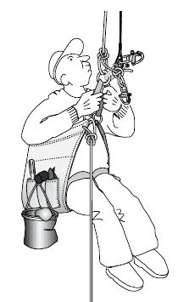
- It is very laborious and time-consuming to winch a person up the mast. The person going up the mast should help.
1. Climb up the mast using the same technique as when climbing a rope.
2. “Walk” up the mast, holding on the halyard and the stays.
3. When the boat is heeled over it may be easier to walk up the leeward shroud or on the mainsail.
- When you reach the “workplace”, fasten yourself to the mast or rigging in such a way that you can move within a circle of about an arm’s length.
- During longer periods of work, a further safety measure is to fix the bosun’s chair to a strong point, in order to relieve the load on the halyard.
- Work as efficiently as possible, but do not neglect safety and thoroughness. Do not drop anything – remember that a tool dropped from the masthead can punch a hole in the deck or injure a crew member.
- On the way down make sure that you do not snag any of the fittings or other projections

3. Assistants
- Lead the halyard round a winch with the smallest possible number of turns, so as to avoid override. If possible, use a winch fixed some distance from the mast – to avoid the risk of being hit by dropped tools. This also makes it easier for the assistant to look up the mast.
- The second security halyard must be operated over a separate winch and by a second assistant.
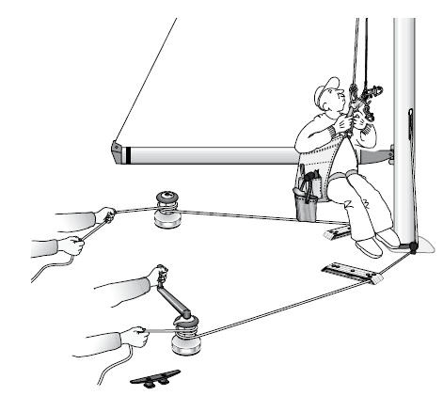
- The halyards must be cleated when the person aloft is in position, even if a self-tailing winch is used.
- When a person is being winched up the mast while under sail, the winching should be temporarily stopped, if the boat sails into a particularly heavy sea.
- Before lowering the person, the line should be checked to ensure that it is free from kinks. Lower at a steady speed and not too slowly.

De mast strijken (winter onderhoud)
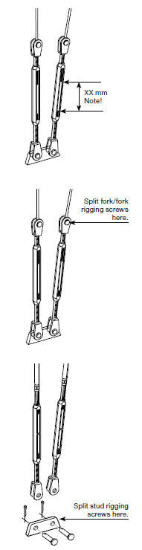
Voorbereiding
- Verwijder de zeilen en berg ze gedurende de winter droog op. Controleer of er reparaties door de zeilmaker uitgevoerd moeten worden.
- Remove any removable parts, such as the spinnaker pole, boom, rigid vang and any appropriate running rigging, including the spinnaker downhaul and main sheet. Secure the end of the boom with the main halyard or topping lift to prevent the boom falling into the cockpit when unfastening the rigid vang. Unreeve the jib furling system’s control line from the fairleads.
- Climb the mast and remove any sensitive equipment if you think that it may be damaged at the crane.
- Make sure the positions of the rigging screws are documented to make it easier to trim the rig in the spring. If not, write down the distance between the ends of the two screws on each rigging screw. Enter your figures on page 80.

Onder de kraan
- Lees het “onder de kraan” gedeelte op pagina 20-21.
- Follow the instructions for your rig type, but in reverse.
- Disconnect the rigging screw from the stay/shroud in the upper part of the rigging screw. This prevents the rigging screws dragging along the ground when the mast is taken down. Re-attach the clevis pins and split pins to the rigging screws to avoid losing them. If the upper part of the rigging screw is a threaded terminal (stud terminal) swaged to the wire, disconnect the rigging screw at deck level.
- Place the mast on trestles.

Staand want
- Wipe over the standing rigging with a cloth and solvent.
- Check stays and shrouds for fraying. If one or more wire strands have failed, the stay or shroud must be replaced by a new one. In this event, change a “complete pair”, i.e. both cap shrouds, both aft lower shrouds etc. The complete pair should be changed even if only one of the wires is damaged. The opposite wire will have been subject to the same stresses. Standing rigging which remains in contact with the mast throughout the winter may cause corrosion damage to the mast due to galvanic reaction between steel and aluminium. The risk of this happening is high in humid and salty atmospheres.
- Disconnect the spreaders and all standing rigging. Remove the spreaders ends from the spreaders. Check for failed wire strands in the area where the spreader end is connected to the shroud. To simplify re-rigging the spreader ends can be left on the shrouds. For linked rigging, there is normally no need to alter the setting of the rigging screws connected to the spreader ends.
- Coil and store the entire standing rigging separately.
- Detach any jib furling systems and remove parts such as line guide, drum and halyard swivel.
- Clean the rigging screw threads using a solvent. Lubricate with Seldén rigging screw oil.

Lopend want
- Remove the running rigging from the mast and replace with thin messenger lines. The messenger line should be carefully tied to the end of a halyard. When the halyard is pulled out of the mast, the messenger line is pulled in. Removal of running rigging eliminates any risk of theft, and allows it to be washed.
- Check the running rigging for unusual wear on cordage, whippings and splices, and for any failed strands of wire. If you should find any worn parts, ensure that you find out what caused it and repair the fault.
- If the running rigging is left on the mast, any wire parts on the halyards should be pulled out of the mast, coiled and prevented from coming into contact with aluminium to prevent galvanic corrosion. Tie a stopper-knot at the free end of the halyard.
- Examine the shackles, particularly any quick-release shackles, for cracks and deformation. Also ensure that they close properly.

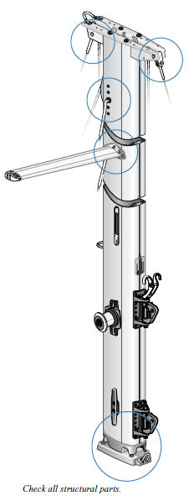
Mast en giek
Anodized sections
- Spoel mast, giek, spinnaker boom, vaste neerhouder en jib furling system met water. Als het kan spoel dan ook de binnenkant.
- Wash with a mild detergent solution, such as dishwashing liquid. Rinse carefully, since most detergents contain substances which may corrode aluminium. Let the components dry. Careful cleaning is particularly important at the foot of the mast, where the mast is most exposed to salt.
- Carefully check all structural fittings for:
Cracks
Deformation
Wear/play
Fastening
Corrosion
Ageing (plastic)
- Check any leads for the genoa halyard. The halyard for a jib furling system is sometimes led through a bronze fitting (halyard lead). If a wire halyard is used, the bronze fitting will wear, rather than the halyard. Replace the halyard lead if you don’t think it will last another season. For more information on this, please see the instructions for Furlex jib furling and reefing system.
- The boom outboard end-fitting is attached with screws. To ensure that these can be removed, the threads should be greased every season. Remove and grease one screw at a time.
- Check that moving parts (sheaves, locking arms on the gooseneck etc.) are not stuck.
- Coat all aluminium sections on the rig in paraffin oil, yacht polish or wax. This seals the pores of the sections and preserves surface shine. Cast metal parts also benefit from this treatment. On Seldén masts, all cast metal fittings are, however, lacquered and therefore permanently protected.

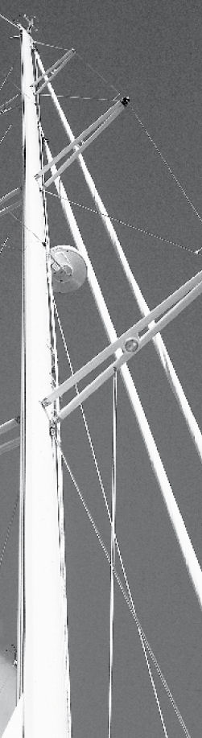
Painted sections

- The maintenance of a painted mast/boom is the same as for anodized equipment. It is, however, important to check, and rectify, any damage which has penetrated the paint. The aluminium section has no protective anodized surface underneath the paint.
- Seldén use powder coatings in their painting process. For touch-up work, you will have to use wet paint. Use a paint which is suitable for use on aluminium, select the correct shade and follow the manufacturer’s instructions.
- Seldén warranty will not cover corrosion on the mast/boom or blistering of the paint associated with any of the items on the list below.
1. Damage to the paint.
2. Fittings mounted to the mast after delivery from Seldén.
3. Holes that are drilled in the mast after delivery from Seldén.

If you wish to cut /drill into the painted mast, please follow the advice below:
- Water and air must not be allowed to get to an exposed edge of the painted mast section. If it does, there is a high probability that, in time, corrosion will spread under the paint causing unsightly blistering.
- To achieve this protection, it is recommended that fittings are bedded down onto the mast with “Mastic Frame Sealant”. If there is an exposed edge, this must be carefully protected with a chromate primer and top-coat.

Beschadigd of cosmetic flaws?
Learn to distinguish between what is to be regarded as damage, and rectified, and what can be regarded as a cosmetic flaw. Try to trace the reason for any imperfection and take necessary measures to avoid it for the future.

Examples­of­damage
- Dent in mast or boom extrusion. Describe the depth, area and location of the dent to your Seldén dealer. We can then suggest what needs to be done.
- A permanent bend in the mast extrusion. If the bend cannot be corrected by rigging adjustments, this is a serious damage. Make contact with Seldén for rebuild with new extrusion, or alternatively, a new mast.
- Corrosion damage to stainless parts, that is corrosion which has gone deep and which cannot be removed by polishing. The part must be replaced.
- Loose fittings. Vervang door de juiste popnagels of schroeven.
- Broken strands. Replace the wire. Also replace the corresponding shroud on the “other side”, if the lateral rigging is involved.
- Any damage to carbon products must be inspected and repaired by a specialist as soon as possible. Carbon is a strong lightweight material, but less tolerant to impact damage than aluminium, so it must be handled with due care. For example, if a carbon spinnaker pole tube is exposed to point loading, a crack can develop. This will weaken the tube, and eventually lead to failure.

Examples­of­cosmetic­flaws
- Scratches and chafing on anodized surfaces such as mast and boom extrusions. Damage to an anodized layer is self-healing, through the material oxidizing. The oxide forms a protective surface over the damage. Polishing and subsequent waxing will also help protect the exposed surface.
- Brown discoloration can occur on all stainless material, and can be removed by polishing.
- Discoloration of carbon products. The products are UV protected but with time the resin surface of the carbon products may discolour and loose the gloss finish. This is normal and has no effect on the performance of the product.

Storage
- The mast, boom and jib furling system should be stored in airy conditions throughout the winter. Luff groves are placed downwards to prevent water accumulating which may result in frost damage. This is particularly important for the jib furling system. The equipment must never be wrapped in plastic or other material, as this will prevent air circulating.
- Avoid storing a painted mast or boom on arms protected with material which can hold water. The moisture will cause blisters in the paint. Carpet and soft woods are worst. Nylon and hard woods are best.
- Using the mast as a ridgepole for a tarpaulin may be practical, but make sure it is well protected from chafe. The anodized layer is only 20 microns (0.020 millimetres) thick and can be worn off by a tarpaulin rubbing against the surface, resulting in permanent imperfections.
- Carbon products are, as mentioned above, sensitive to point loading and must be handled with care.

Mounting new fittings
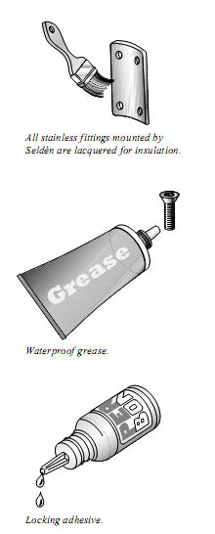
- To minimise the risk of corrosion, insulation must be placed between the fittings and the mast section if these are of dissimilar metals. Use a zinc chromate primer or similar. You can also use a spacer, e.g. a nylon disc (included with Seldén fittings). The risk of corrosion is particularly high when marine grade steel fittings are attached to aluminium. The corrosion risk increases with the size of the contact surface. Fittings made from brass or other copper-based alloys should never be fitted in such a way that they come into contact with aluminium.
- Bearing in mind the risk of corrosion, monel pop rivets are the best choice for fastenings, particularly when attaching something to a thin-walled (< 3 mm) section. The pop rivet body should extend inside the section by 1.0-1.5 x diameter. The pop rivet mandrel should always be punched out as these are made out of carbon steel and may discolour the mast when they rust.
- If machine screws are used, they should be insulated with locking adhesive, waterproof grease or anti-corrosive paste.
- Specialist knowledge and tools are required for any modification to carbon products.

Masten die blijven staan
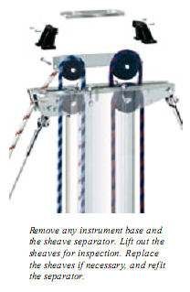
Regular inspection of the rig is obviously essential even if the mast is not unstepped in the autumn. On a stepped mast, the work has to be done from a bosun’s chair. Follow the “Winter maintenance” instructions, and check all structural and moving parts.
Seldén masts from 2003* and onwards are equipped with a masthead fitting which makes it easy to check and replace halyard sheaves. There is no need to lower the mast to remove the sheaves.
The larger sections (F324-F370; E321-E365) feature a similar design.

*Section C211-C304; F212-F305

Boot op de wal met staande mast
- Verminder de spanning van het laterale want (voorstag / achterstag) een beetje, net genoeg om de romp wat minder te belasten. Geen enkel deel van het staande mag slap staan. Slappe verstaging veroorzaakt schade tijdens de winter.
- Make sure your cradle is strong enough for the loads created by the windage of the rig.
- Do not forget to do the winter maintenance of your rig!

Enkele rekenprincipes t.a.v. mast en want
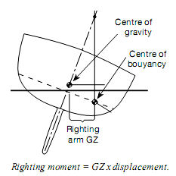
Righting/heeling­moments
A rigging calculation is based largely on the yacht’s righting moment, i.e. the yacht’s resistance to the heeling force of the wind. The greater the yacht’s resistance, the greater the forces
generated in the rig. A large sail area in a light wind has the same effect as a small sail area in a strong wind as far as heeling moment is concerned.
The righting moment, often abbreviated to “RM”, is largely determined by the yacht’s displacement, keel weight, beam and draft.

Shrouds­and­stays
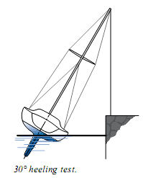
The forces affecting the shrouds are calculated using the principle that the shroud must be able to withstand the heeling force of the wind and the yacht’s RM. The maximum actual force is multiplied by a safety factor, and this gives the required breaking load for every shroud. Suitable dimensions of wire or rod are then selected to meet the breaking load conditions. The safety factor is chosen so that the shrouds, in addition to having a sufficient breaking load, will have good fatigue strength (= service life) and low stretch under load.

The forces in the longitudinal rigging and the running rigging are based on values gained from experience. The forces involved are usually closely related to the yacht’s righting moment, even though they are generated by the crew trimming the rig.

Mast
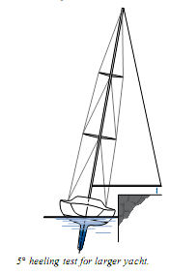
The mast compression is calculated first. The factors involved are:
1. Forces in the lateral rigging (the shrouds) primarily related to the yacht’s RM, and chain plate beam.
2. Forces in the longitudinal rigging.
3. Forces in the running rigging.

The dimensions of the mast extrusion are determined by:
1. The mast compression.
2. The height above deck of the forestay.
3. The location of the mast foot (on deck or on the keel).
4. The number of pairs of spreaders.
It is the distance between “staying points” which, along with mast compression, determines the dimensions of the mast extrusion. Staying points are at deck level, the spreader fittings and the cap shroud fitting. The longitudinal stability of the mast must be calculated separately. Staying points in this direction are the fastenings of forestay, backstay, double lower shrouds, baby stay, inner forestay, cutter stay/runners, check stays and spreader brackets for swept spreaders.

Boom
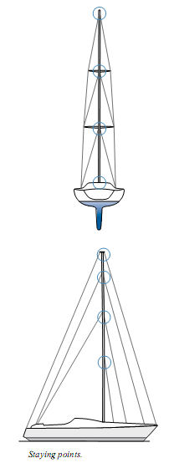
The strength required from the boom depends on the force from the vang, also closely related to the RM, the force from the mainsheet and the length of the boom. The location of the sheeting point is also very important (boom-end sheeting or centre-sheeting).

Jib­furling­system
The jib furling system is exposed both to vertical forces (halyard loads), and to torsion (twisting forces) in the extrusion. Both are determined by the crew. Torsion arises when sailing with a partly rolled sail. Sheet load related to the yacht’s RM determines how great the torsion becomes, and is therefore critical for dimensioning. We also take into account the yacht’s rig type. A masthead rigged yacht has relatively larger loads in the foresail than a fractionally rigged yacht. That is why our versions of the Furlex jib furling system have different “RM-limits”, depending on rig type.

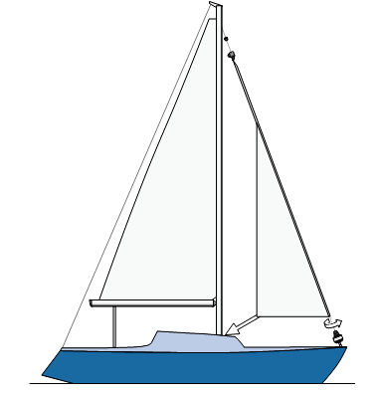

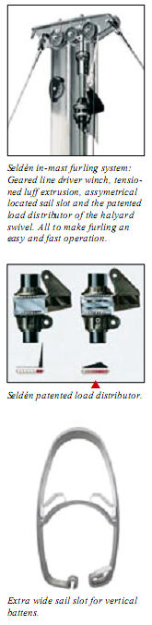
Positive roach + in-mast furling
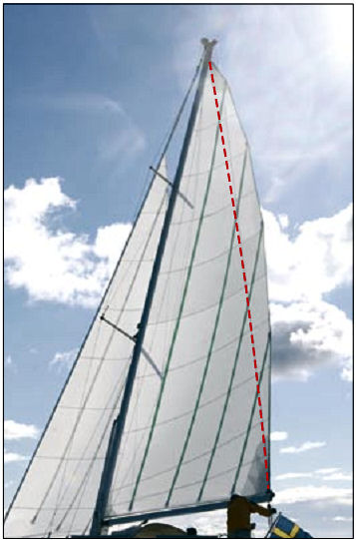

Anyone who imagines that a furling sail is less efficient because it cannot provide sufficient roach would be wrong. The new Seldén in-mast furling masts are made for vertical battens and a true positive roach.

Sail Slides and sail entry
MDS­full­batten­system
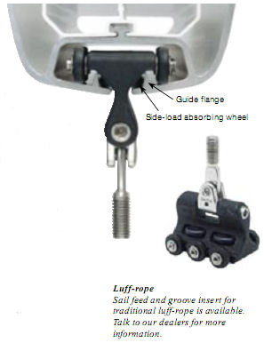
Seldén MDS-cars (Multi Directional Support) are supported in all directions, making sail handling simpler. A full batten always creates a side load on the cars, particularly when you release the
halyard for taking a reef. The side load absorbing wheels of the car run along guide flanges in the mast groove, allowing simple and low friction mainsail handling. The sail entry is removed when installing or removing the cars. Please note that the full-batten fitting must be able to swivel freely to avoid subjecting the car to unnecessary torque.

Sail­slides
For sails with conventional slides, use the spring-loaded mid section of the sail entry.
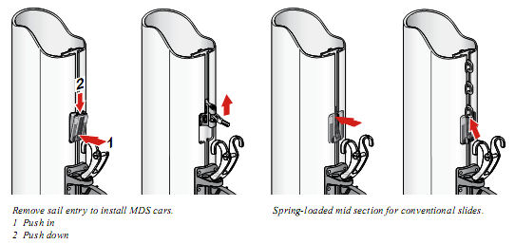

The Selden product range

